Ecosystem Diorama!
Due: Friday, September 19th

As a scientist, you have been given the task to create an ecosystem. An ecosystem is a complex set of relationships among the living resources, habitats, and residents of an area. It includes plants, trees, animals, fish, birds, microorganisms, water, soil and people.

Ecosystems vary greatly in size and the elements that make them up, but each is a functioning unit of nature. Everything that lives in an ecosystem is dependent on the other species and elements that are also part of the ecological community. If one part of an ecosystem is damaged or disappears, it has an impact on everything else.

When an ecosystem is healthy, scientists say it is sustainable. This means that all the elements live in balance and are capable of reproducing themselves. There is usually biodiversity, which means there are a variety of living organisms and species in that environment.

You must create an ecosystem diorama that displays all the different parts of an ecosystem and shows how they all interact in order to survive. Create a narrative to go along with your diorama to describe what is happening and how the different parts of your ecosystem work together to create a sustainable environment. Be creative!
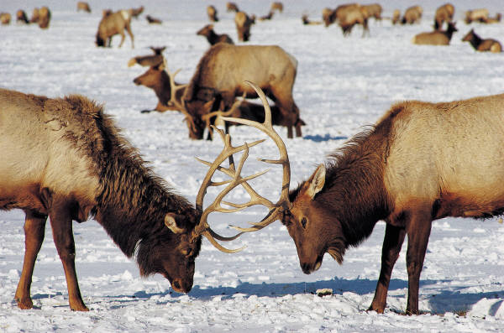

Rubric
4 Points | 3 Points | 2 Points | 1Point
Student accurately portrays all aspects of the ecosystem | Student somewhat accurately portrays all aspects of the ecosystem | Student is missing some aspects of the ecosystem | Student is missing several aspects of the ecosystem
Student accurately describes through his or her writing what is happening in the ecosystem and the different parts being displayed | Student somewhat accurately describes through his or her writing what is happening in the ecosystem and the different parts being displayed | Student has a few errors through his or her writing about what is happening in the ecosystem and the different parts being displayed | Student has several errors through his or her writing about what is happening in the ecosystem and the different parts being displayed
Student demonstrates a lot of creativity and detail in the diorama | Student demonstrates some creativity and detail in the diorama | Student demonstrates little creativity and detail in the diorama | Student demonstrates no creativity and detail in the diorama

